Appendix B

Local Government Boundary
Commission for England

New Electoral Arrangements for Harrow Council (December 2018)

Harrow Council’s Response to the Local Government Boundary Commission for England’s Draft Recommendations

February 2019

Contents
Introduction 4

Warding Arrangements 5
Belmont 5
Canons 5
Centenary 5
Edgware 5
Greenhill 5
Harrow on the Hill 6
Harrow Weald 6
Hatch End 6
Headstone 6
Kenton East 8
Kenton West 8
Marlborough 8
North Harrow 9
Pinner 11
Pinner South 11
Rayners Lane 13
Roxbourne 16
Roxeth 17
Stanmore 17
Wealdstone East & Wealdstone West 17
West Harrow 20

Introduction

This report sets out Harrow Council’s response to the Local Government Boundary Commission for England’s (LGBCE) Draft Recommendations on the Future Electoral Arrangements for Harrow Council.
In summary, the Council welcomes the Commission’s draft recommendations in supporting the Council’s own submission in a large number of wards, but there are a number of areas where we would like the Commission to re-examine their proposals.
In general the Council accepts the Commission’s decision to use the railway lines in the borough as ward boundaries to a far greater extent than they have been used as boundaries in the past. However, we would like the Commission to reconsider the boundaries of Rayners Lane ward, in particular, where using the Metropolitan and Piccadilly lines as the new northern boundary of this ward simply does not work, as it divides the community in this area, as well as splitting this vibrant district centre into three wards.
We are pleased to see that the Commission supports a new ward in North Harrow, but we feel that the proposed boundaries could still be improved to some extent.
With regard to Roxbourne ward the Council seeks to retain this ward as a three-member ward. Members cite that their caseload is higher in this ward, largely due to the higher levels of deprivation in this area.
The Council has no objections to the Commission’s proposed outer boundaries of Wealdstone East and Wealdstone West wards. However, we are unhappy that the district centre has been split between two wards, so the Council proposes to reunite Wealdstone town centre in one ward, namely Wealdstone East.
The Council’s detailed comments can be found on the following pages, together with maps showing the Council’s proposed new ward boundaries, where appropriate. The blue shaded areas on the maps indicate Harrow’s town centres.
With regard to ward names, the Council is still pursuing the renaming of some of Harrow’s wards. In particular we do not like the geographical locator (eg East) to follow the place name (eg Kenton East), so if a complete ward renaming is unacceptable then simply changing the name to ‘East Kenton’ would be more acceptable.
These further proposals were considered by the Council’s Licensing and General Purposes Committee on 6th February 2019.

Warding Arrangements

Belmont
The Council has no objection to the LGBCE’s proposed boundaries for Belmont ward. We are pleased that the whole of Belmont Local Centre has been located within this ward.

Canons
The Council is pleased that the Commission has endorsed the Council’s proposed boundaries for Canons ward.

Centenary
The Council is pleased that the Commission has accepted the Council’s proposals for this ward and that they are recommending that the name of this ward (previously Queensbury) reverts back to Centenary, which the Council supports.

Edgware
The LGBCE’s recommendations for Edgware ward endorse the Council’s proposed boundaries for this ward, so that is to be welcomed. This is a densely populated and busy area bordering the London Boroughs of Barnet and Brent. The ward also contains parts of Edgware Major Centre and Burnt Oak District Centre. It is important to the Council that this ward continues to function as a three-member ward.

Greenhill
The Council accepts the LGBCE’s proposals for the three-member Greenhill ward, but proposes one minor change. The current southern boundary of Marlborough ward with Greenhill ward bisects the northern part of Harrow Metropolitan Centre. We are therefore proposing that the ward boundary should follow the Metropolitan Centre boundary, therefore transferring the following properties from Marlborough ward into Greenhill ward:
  - Tesco Superstore
  - Safari Cinema/V2V Community Church
  - Dominion Parade
  - 2-8 Hindes Road (evens)
With just 32 electors identified on the 2018 Electoral Roll for this area, these amendments would have a negligible effect on the electoral variances of these two wards.

© Crown copyright and database rights 2019 Ordnance Survey 100019206
Harrow on the Hill
The Council is pleased that the Commission has chosen to endorse the Council’s proposed boundaries for this two-member ward.

Harrow Weald
The Council is pleased that the Commission has endorsed the Council’s proposed boundaries for Harrow Weald ward, with no additional changes.

Hatch End
The Council accepts the Commission’s draft recommendations for Hatch End ward, with the realigned boundary with Pinner ward, together with the inclusion of Hatch End High School and the older settlements around Chantry Road and Letchford Terrace within this ward.

Headstone
The Council accepts the Commission’s draft recommendations for the new three-member Headstone ward, but proposes a minor change to the south-west of this ward. It is acknowledged that this is now a very long ward covering a number of different communities from north to south.
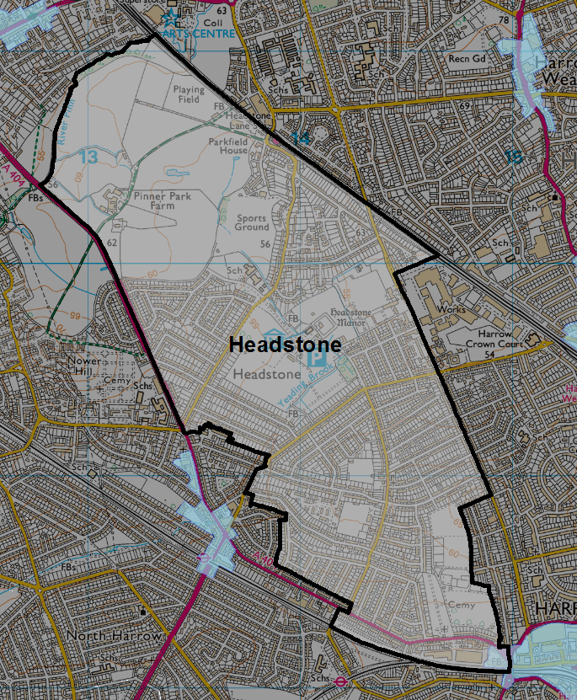
The Council proposes that three roads adjacent to North Harrow District Centre are relocated to North Harrow ward. These roads are:
© Crown copyright and database rights 2019 Ordnance Survey 100019206
  - Cumberland Road
  - Gloucester Road
  - Westmorland Road
In addition we strongly believe that The Salaam Centre (North Harrow Community Centre), currently under construction adjacent 39 Gloucester Road, should definitely be located in North Harrow ward.
We acknowledge that the Commission is reluctant to split the ‘county roads’ (Para 73 of Draft Recommendations) for fear of splitting a community in two. However, the Council has reconsidered its earlier proposals and is of the opinion that the ‘county roads’ are two distinct communities with the character of the area changing around Durham Road. The properties in the western part of the ‘county roads’ were constructed in the late 1920s and are largely semi-detached houses, whereas Edwardian terraces predominate in the eastern ‘county roads’. Gloucester Road and Cumberland Road (leading into Westmorland Road) also feed off Station Road and residents are within easy walking distance of all the services and facilities of North Harrow District Centre. The Council therefore considers that these roads should be located in North Harrow ward.
We note that in Para 75 of the Draft Recommendations that you refer to Headstone Common Station - this should be Headstone Lane Station.
Based on the 2024 predicted electorate figures there will be an estimated 10,340 electors in the Council’s proposed Headstone ward (3,446 electors per councillor) giving an electorate variance of +2.1% for this three-member ward.

Kenton East
The Council is happy to accept the Commission’s Draft Recommendations for a three-member Kenton East ward, modelled on the Council’s submitted scheme with a few minor amendments. We note that the Commission is reluctant to recommend a name change for this ward to avoid losing the identity of the area. However, the Council would like the Commission to give consideration to changing the ward name to East Kenton. This name which would still keep the identity of the area, but would avoid confusion in matters concerning the London Assembly, as the London Borough of Brent has a ward called Kenton and Brent & Harrow forms a single constituency on the London Assembly.

Kenton West
The Council endorses the Commission’s proposed boundaries for a two-member Kenton West ward, which essentially follows the Council’s suggested boundaries for this ward. The Commission’s suggested changes to the northern boundary of this ward with Belmont ward provide a better relationship with Belmont Local Centre.
We note that the Commission is reluctant to recommend a name change for this ward to avoid losing the identity of the area. However, the Council would like the Commission to give consideration to changing the ward name to West Kenton. This name which would still keep the identity of the area, but would avoid confusion in matters concerning the London Assembly, as the London Borough of Brent has a ward called Kenton and Brent & Harrow forms a single constituency on the London Assembly.

Marlborough
The Council accepts the LGBCE’s proposals for the three-member Marlborough ward, but proposes one minor change. The current southern boundary of Marlborough ward with Greenhill ward bisects the northern part of Harrow Metropolitan Centre. We are therefore proposing that the ward boundary should follow the Metropolitan Centre boundary, therefore transferring the following properties into Greenhill ward:
  - Tesco Superstore
  - Safari Cinema/V2V Church
  - Dominion Parade
  - 2-8 Hindes Road (evens)
With just 32 electors identified on the 2018 Electoral Roll for this area, these amendments would have a negligible effect on the electoral variances of these two wards.
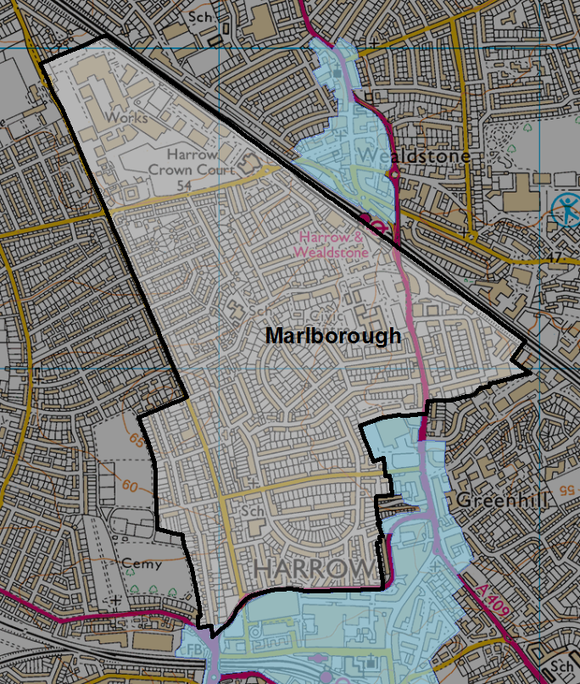
© Crown copyright and database rights 2019 Ordnance Survey 100019206
North Harrow
The Council welcomes the Commission’s Draft Recommendations to create a new two-member North Harrow ward. However, we wish to suggest a number of further changes to the boundaries of this ward.
Firstly, the Council proposes that three roads adjacent to North Harrow District Centre are relocated to North Harrow ward.
These roads are:
  - Cumberland Road
  - Gloucester Road
  - Westmorland Road
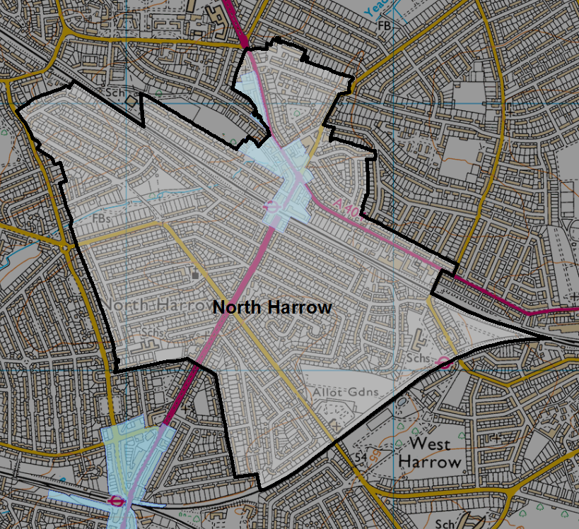
Our justification for including these roads in North Harrow ward are detailed under our comments on Page 6 (Headstone).
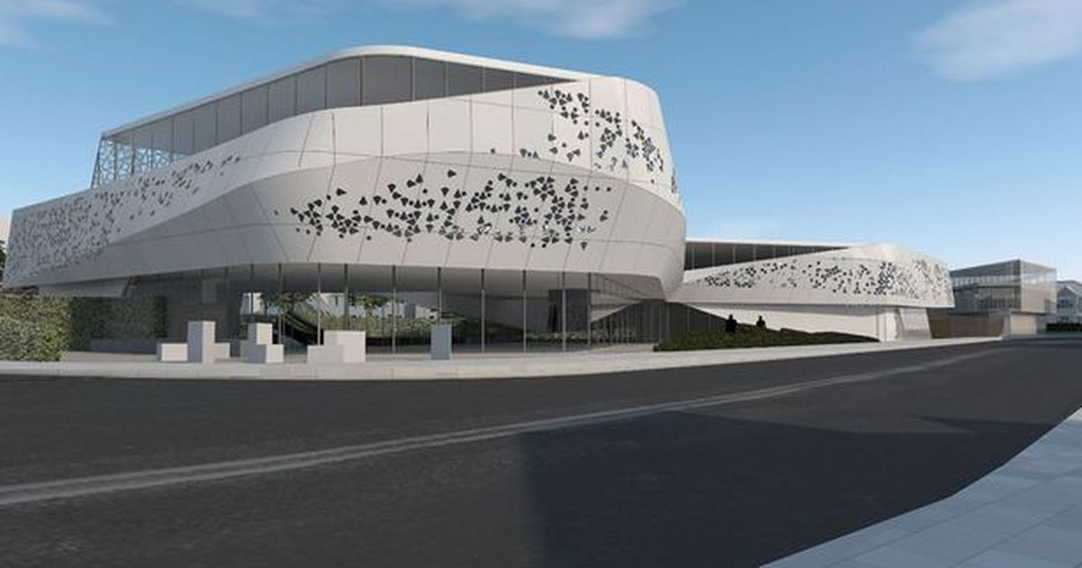
In addition we strongly believe that The Salaam Centre (North Harrow Community Centre), currently under construction adjacent 39 Gloucester Road, should definitely be located in North Harrow ward. As the photo shows, this promises to be an iconic building and it is situated in the heart of North Harrow town centre facing onto Station Road. We therefore feel that it belongs to North Harrow ward, not Headstone.
© Crown copyright and database rights 2019 Ordnance Survey 100019206
The second change which the Council is proposing for this ward is the transfer of an area north of Yeading Walk from Pinner South ward into North Harrow ward.
The roads affected by this move include:
  - Lincoln Road
  - Lincoln Close
  - The Ridgeway (north of Lincoln Road)
  - Northumberland Road (north of Yeading Brook)
  - Mount Drive
  - Grove Road
The Council feels that this area fits neatly within North Harrow ward and would reunite properties in The Ridgeway and Northumberland Road with those currently in this ward. In Para 68 of the LGBCE’s Draft Recommendations it is stated that “We also note that all the roads to the north of Yeading Walk have good access into our proposed Pinner South ward via Rayners Lane”. The Council believes that this statement equally applies to North Harrow ward with regard to this area.
Finally, because the Council is suggesting a number of changes to Rayners Lane ward a large number of properties in the south-west of North Harrow ward would be relocated to Rayners Lane ward, as per the Council’s original submission. These properties are all within easy walking distance of Rayners Lane District Centre, some located within the town centre itself including a number of commercial premises. The properties/roads affected are:
  - Farm Avenue (odds)
  - Park Drive
  - Imperial Drive, 104-142 (evens) & 107-247 (odds)
  - The Drive (evens)
  - Vicarage Way
  - Elm Grove
  - Oakington Avenue
  - Beechcroft Avenue
Based on the 2024 predicted electorate figures there will be an estimated 7,260 electors in the Council’s proposed North Harrow ward (3,630 electors per councillor) giving an electorate variance of +3.1% for this two-member ward.

Pinner
The Council endorses the LGBCE’s recommended boundaries for this ward and we reiterate that we would like this ward to be renamed Pinner Village. Pinner covers quite a large expanse of the borough to the north-west and there are two Pinner wards. Pinner was originally a medieval hamlet and the oldest surviving buildings in Pinner are located within this ward. The new name of Pinner Village reflects the heritage of this area.

Pinner South
The Council wishes to propose a number of changes to the boundaries of Pinner South ward, as detailed in the Commission’s Draft Recommendations. These changes would mean that Pinner South ward would become a two-member ward. The Council’s proposed changes affect the southern and eastern boundaries of Pinner South ward. However, the Council has no objections to the Commission’s boundary proposals for the northern part of this ward.
The main justification for the Council’s changes is to give Rayners Lane ward back its true identity and boundaries, as detailed in our original submission. We are therefore proposing that the southern boundary of Pinner South ward follows along the rear of the properties to the north of Eastern Avenue and Village Way and then follows Yeading Brook, a strong natural boundary. Our detailed justification for defending these boundaries can be found on Page 13 of this submission (Rayners Lane).
Additionally, in order to achieve acceptable electoral variances in Pinner South ward, we are proposing that an area to the north-east of this ward, abutting the Metropolitan Line, is moved into the new North Harrow ward. The properties affected by this move include:
© Crown copyright and database rights 2019 Ordnance Survey 100019206
  - Lincoln Road
  - Lincoln Close
  - The Ridgeway (north of Lincoln Road)
  - Northumberland Road (north of Yeading Brook)
  - Mount Drive
  - Grove Road
The eastern boundary of Pinner South ward would then follow along the rear of the properties on the eastern side of Rayners Lane, consistent with our Rayners Lane ward boundary to the south. It is felt that this area fits neatly within North Harrow ward and would reunite properties in The Ridgeway and Northumberland Road with those in the current North Harrow ward. Yeading Brook, whilst being a natural boundary, is easily crossed at Northumberland Road and Rayners Lane. In Para 68 of the LGBCE’s Draft Recommendations it is stated that “We also note that all the roads to the north of Yeading Walk have good access into our proposed Pinner South ward via Rayners Lane”. The Council believes that this statement equally applies to North Harrow ward with regard to this area.
In line with other wards currently with a geographical identifier following the place name, it is proposed to give this ward another name. Pinner West End is deemed to be a suitable name, taking the West End component from West End Lane and West End Avenue, named after another medieval hamlet which existed in this area. In the 1860s Lord Nelson’s daughter Horatia lived at West End Lodge, which was situated opposite West House. Pinner Memorial Park was formed from the grounds of West House, the latter now a museum. West End Lodge no longer survives, but West Lodge School, on the site of West End Lodge, was so named to reflect the history of this area. It is therefore felt that Pinner West End would be a better name for this ward.
Based on the 2024 predicted electorate figures there will be an estimated 7,603 electors in the Council’s proposed Pinner South ward (3,802 electors per councillor). This gives an electorate variance of +8% for this two-member ward, which is the same variance level as currently detailed in the Commission’s Draft Recommendations.

Rayners Lane
The Council is dissatisfied with the Commissions proposal’s for Rayners Lane ward. We are therefore proposing that the Commission reconsiders the Council’s scheme for this two-councillor ward.
Since our original submission the Council has revised part of the northern boundary (to the west) of this ward with the inclusion of the following properties in Rayners Lane ward:
  - 122-140 Village Way (evens)
  - Hardy Close (all)
  - Frobisher Close (all)
  - Raleigh Close (all)
  - Rodney Close (all)
  - 2-76 Eastern Avenue (evens)
The inclusion of these properties realigns the ward boundary along the north side of Eastern Avenue and Village Way, encompassing Hardy Close, Frobisher Close, Raleigh Close and Rodney Close, which feed off Eastern Avenue, giving a more coherent boundary following LGBCE guidelines more closely. This serves to give better access and justification for including the housing estate off Cannon Lane and adjacent to Roxbourne Park within Rayners Lane ward.

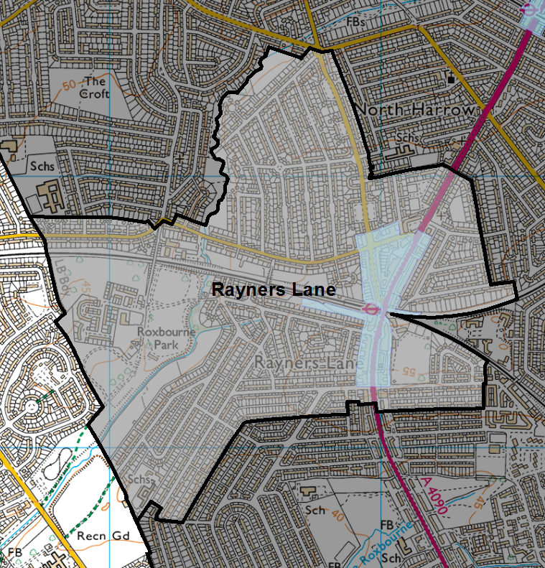
The Commission’s draft proposals use the Metropolitan and Piccadilly lines as the northern boundary of Rayners Lane ward. The Council is not in favour of this proposal, as we consider that Rayner’s Lane Station and the whole of the Rayners Lane District Centre is situated in the heart of this ward. Moving this boundary to the railway line ignores the history of this centre and cuts ‘the high street’ (Imperial Drive/Alexandra Avenue) in half.
© Crown copyright and database rights 2019 Ordnance Survey 100019206
Rayners Lane ward derives its name from the lane named after the Rayners family (Rayners Lane) and the current proposal ignores the history of this ward and the origins of the Rayners Lane community. Under the proposed LGBCE boundaries a large portion of Rayners Lane would actually fall outside this ward.
The northern boundary of Rayners Lane ward should continue to follow Yeading Brook (aka River Pinn), a clearly defined physical boundary. This has been the current ward boundary for at least 40 years and we see no reason for this to now be changed. This area in question is known as Harrow Garden Village and includes, amongst other roads, The Avenue, Central Avenue, West Avenue, Hillcroft Avenue, Church Avenue, Downs Avenue and The Glen. The estate was developed by Metropolitan Railway Country Estates (MRCE).
Harrow Garden Village is primarily accessed off Village Way and Rayners Lane and is within easy walking distance of Rayners Lane Station, as illustrated in the 1929 poster promoting the estate (below).
The 1929 issue of Metro-land made first mention of the MRCE’s plans for Harrow Garden Village, referring to the 1,000 houses and 240 shops to be built on a layout of ‘wide avenues, generous circles, closes and open spaces’. This highlights the integral links of the estate with Rayners Lane shopping centre.
The Council is not disputing the fact that residents in this area may also use the facilities in Pinner District Centre, but these facilities are further away, whilst Rayners Lane town centre is adjacent. Moving Pinner South ward as far south as the Commission’s draft recommendations has extended Pinner way beyond its historical boundaries whilst ignoring the historical significance of the Rayners Lane area. These changes effectively exile Rayners Lane from its historical and natural boundaries, with the only remaining link to the area historically recognised as Rayners Lane being the ward name.
Part of this confusion is due to the postcode in this area which the Royal Mail has assigned as HA5, which stretches through Pinner, Rayners Lane and into North Harrow. Postcodes should not be a factor in determining communities or ward boundaries. Similarly estate agents tend to exaggerate the geography of a location in order to make properties more desirable and this is a factor which needs to be ignored. We would therefore like to reiterate the fact that Harrow Garden Village should remain in Rayners Lane ward with Yeading Brook acting as a good natural ward boundary.
With regard to the remaining boundaries of Rayners Lane ward the Council would like the LGBCE to reconsider the previous boundaries submitted by the Council. We wish to extend the boundary north of the Metropolitan and Piccadilly lines, so that the whole of the Rayners Lane District Centre and adjoining roads are included within Rayners Lane ward. The town centre is currently split between three proposed wards (Rayners Lane, Pinner South and North Harrow) and this is not acceptable.
Similarly the southern boundary of this ward with Roxbourne ward remains unchanged, in order to retain Roxbourne as a three-member ward. However, we do accept that some minor changes would be acceptable in this area where the Nash estate is situated and has to be divided between these two wards.
Based on the 2024 predicted electorate figures there will be an estimated 6,985 electors in the Council’s proposed Rayners Lane ward (3,493 electors per councillor) giving an electorate variance of -0.8% for this two-member ward.

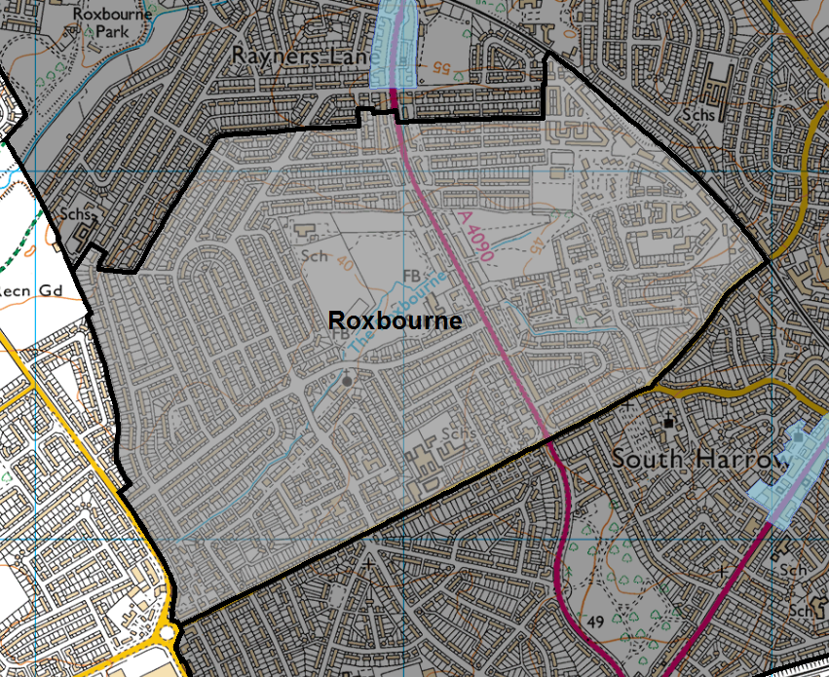
Roxbourne
The Council has considered the draft recommendations made by the LGBCE for Roxbourne ward. It is good to see that the Commission has recommended adopting the southern and eastern boundaries proposed by the Council in our original submission. We are also pleased that the Rayners Lane Estate is fully contained within this ward, as this area was Harrow’s most deprived Lower Super Output Area (LSOA) for Multiple Deprivation in the 2015 Indices of Deprivation and was one of two LSOAs in Harrow amongst the top 20 per cent of England’s most deprived LSOAs. Whilst this estate has been completely rebuilt in recent years it is extremely important that the Council, and others, monitor the effects of this regeneration over time.
© Crown copyright and database rights 2019 Ordnance Survey 100019206
With continuing higher levels of unemployment, vehicle crime, criminal damage and arson in this area, coupled with the higher levels of deprivation, the Council seeks to retain Roxbourne ward as a three-councillor ward. We would therefore like the Commission to reconsider the northern boundary of this ward and the Council is therefore proposing the same boundaries as in our previous submission, whilst accepting that this could perhaps be tweaked. Newton Park West and Newton Farm Ecology Park (incorrectly referred to as Newtons Park on Page 15 of the Draft Recommendations) are important recreational facilities for residents in this area and we do not consider that “they disrupt transport links through the ward”, as stated in your report.
The large Nash estate (Tithe Farm Estate), built largely in the 1930s extends from the Metropolitan Line to the north (in Rayners Lane ward) right down to Eastcote Lane and contains over 4,500 houses, as well as flatted developments along Alexandra Avenue. This large estate can therefore not be entirely contained within just one ward, so it is inevitable that this estate has to be split between two wards.
Ward variances and electoral numbers therefore remain unchanged from the Council’s original submission.

Roxeth
The Council is pleased that the Commission has endorsed the Council’s proposed boundaries for a three-member Roxeth ward in their entirety.

Stanmore
The Council endorses the LGBCE’s draft recommendations for a three-member Stanmore ward and are happy that the Commission has no objection to the ward name change from Stanmore Park to Stanmore which better reflects the whole area.

Wealdstone East and Wealdstone West
The Council largely accepts the LGBCE’s proposals for the three-member Wealdstone East ward and the two-member Wealdstone West ward, but proposes two changes.
Wherever possible the Council does not wish to see the borough’s designated District and Local Centres bisected by ward boundaries. We are therefore seeking to reunite all such centres within one ward, particularly in respect of the District Centres. Currently the LGBCE’s Draft Recommendations splits Wealdstone District Centre between Wealdstone East and Wealdstone West wards. We therefore propose that all of Wealdstone District Centre falls within Wealdstone East ward, with the town centre boundary forming the ward boundary in this area.
Properties affected include:
  - All properties on the northern side of Headstone Drive between Cecil Road and High Street including Holy Trinity Church and the sub-station adjacent to Cecil Road
  - 35-111 High Street (odds)
  - Sovereign House, Graham Road
  - Cardinal Way
  - Ambassador House & Baptist Hall, Wolseley Road
  - 1b Gordon Road
By realigning this ward boundary the proposed new Wealdstone Square, adjacent to Holy Trinity Church, would be located entirely within Wealdstone East ward. This regeneration project is aiming to give a strong community identity to this area and it is important that this area falls entirely within one ward. All the proposed new large regeneration sites would therefore be located within Wealdstone East ward. The existing Wealdstone ward is currently Harrow’s most deprived ward and it is important that the Council, and other service providers, continue to have the best available statistics to monitor the effects of regeneration in this area over time. Splitting the town centre area between two wards would make this task much harder and the statistics would be less meaningful if split between wards.
The Council is proposing a second change in this ward in order to avoid creating larger electoral variances between Wealdstone East and Wealdstone West wards. We are therefore proposing that a number of properties to the north of the proposed Wealdstone East ward are moved into Wealdstone West ward to help counter the move of the town centre properties from Wealdstone East to Wealdstone West, as detailed above. We do not feel that the LGBCE’s overall boundaries for these two wards are compromised in any way by adopting these changes.
Properties affected in this part of Wealdstone East ward include:
  - Meridian Court, Risingholme Road and High Road
  - Risingholme Road
  - Newton Road
  - Risingholme Close
In addition we would like to point out that Long Elmes has been incorrectly referred to as Long Elmes Road on Page 25 of the Draft Recommendations report.
© Crown copyright and database rights 2019 Ordnance Survey 100019206
With regard to ward names the Council is not in favour of the names Wealdstone East and Wealdstone West. As previously mentioned, the Council is keen to minimise the number of ward names in the borough with a geographical locator following the area name. We are therefore proposing that Wealdstone East simply takes the name of Wealdstone as this proposed new ward reflects the heart of the Wealdstone area. The name Wealdstone was established in the area in the late 1800s and Wealdstone went on to become an important industrial centre. The Council is keen to retain the identity of this ward in the future as the area continues to evolve through a number of major regeneration projects.
The Council favours the name ‘Whitefriars’ for Wealdstone West ward. Although Wealdstone has a proud heritage, this area is also one of the most deprived parts of the borough and we therefore want to give a new identity to part of this area. In Para 86 of your Draft Recommendations it is stated that “the two-councillor Wealdstone West ward is predominantly residential”. We therefore feel that Whitefriars is an appropriate new name for this largely residential area. The name has been chosen to reflect the glassworks that originally stood in this general area, which was Britain’s longest running glass house. Whitefriars glass is world famous, particularly amongst collectors, and it would be fitting for this ward to bear this name. Several streets in this area (Whitefriars Drive and Whitefriars Avenue) were named after the Whitefriars Glassworks, as was Whitefriars School, which is situated in the heart of this new ward.
Based on the 2024 predicted electorate figures there will be an estimated 9,744 electors in the Council’s proposed Wealdstone East ward (3,248 electors per councillor) giving an electorate variance of -7.7% for this three-member ward.
© Crown copyright and database rights 2019 Ordnance Survey 100019206
For Wealdstone West the estimated 2024 electoral variance would be -5.2% for this two-member ward. This is based on the 2024 predicted electorate figures of 6,676 electors in the Council’s proposed Wealdstone West ward (3,338 electors per councillor).
West Harrow
The Council largely accepts the LGBCE’s proposals for West Harrow ward. However, we suggest that the northern boundary is tweaked slightly so that West Harrow Station actually falls within this ward and not within North Harrow ward.

